**Name:_____________________ Date:___________________**

**5.2.2.7. Work Period –Multiplying Fractions by Fractions Using an Algorithm**

**Directions:** Multiply each set of fractions to find the product. Be sure your answer is in simplest form!

**Remember: $\frac{a}{b}$** x =

1. x = 2. x = 3. x =

4. x = 5. x = 6. x =

7. Elijah is baking sugar cookies. The recipe uses $\frac{3}{4}$ cup of sugar. Elijah wants to make one half of the batch. How many cups of sugar does he need? Show your work.



8. Ashley has $\frac{4}{5}$ of a quart of milk in the fridge. She uses one third of this milk for her cereal. How much milk did Ashley use? Show your work.

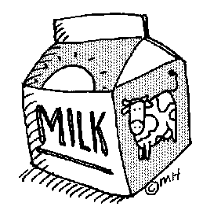

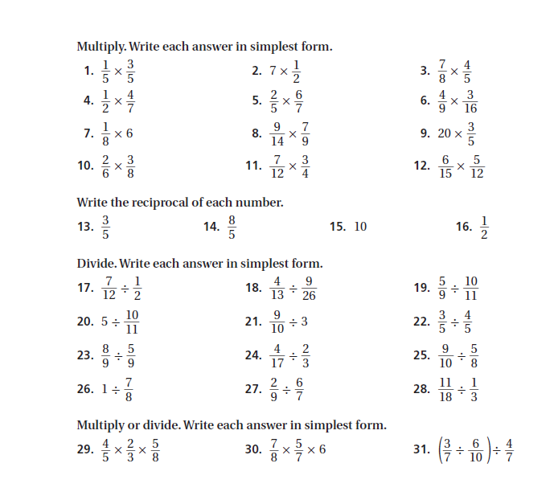

**Dividing Fractions**

There are 3 Simple Steps to Divide Fractions:

Step 1. Turn the second fraction upside-down this is now a [reciprocal](http://www.mathsisfun.com/reciprocal-fraction.html)

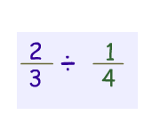Step 2. [Multiply](http://www.mathsisfun.com/fractions_multiplication.html) the first fraction by that reciprocal

Step 3. Step 3. [Simplify](http://www.mathsisfun.com/simplifying-fractions.html) the fraction

**Example 1:**

|  |  |  |
| --- | --- | --- |
| 1 | ÷ | 1 |
|  |  |
| 2 | 6 |

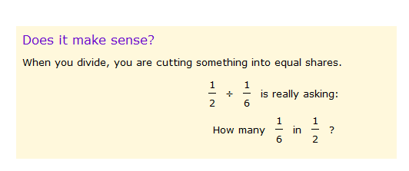Example 2 :



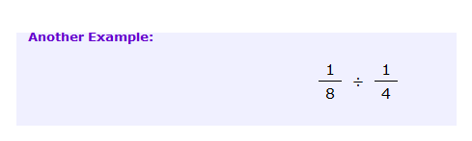

**Name:_____________________________________ Date:___________________**

**5.2.2.7. Homework –Multiplying Fractions by Fractions Using an Algorithm**

**Directions:** Solve each problem and find the answer in the box. Place the letter corresponding to the answer in the blanks to answer the riddle.

|  |
| --- |
| Description: http://www.how-to-draw-funny-cartoons.com/image-files/cartoon-mosquito-9.gifDescription: http://www.how-to-draw-funny-cartoons.com/image-files/cartoon-mosquito-9.gifDescription: http://www.how-to-draw-funny-cartoons.com/image-files/cartoon-mosquito-9.gif **K B E G**  **N I $\frac{2}{7}$ R $\frac{4}{5}$ S $\frac{3}{14}$** |

1. $\frac{4}{9}$**x $\frac{3}{7}$**
2. $\frac{2}{3}$**x $\frac{3}{7}$**
3. $\frac{3}{5}$**x $\frac{3}{7}$**



1. $\frac{1}{2}$**x $\frac{3}{7}$**

**What is a mosquito’s favorite sport? _____ _____ _____ _____ diving.**

**4 3 2 1**